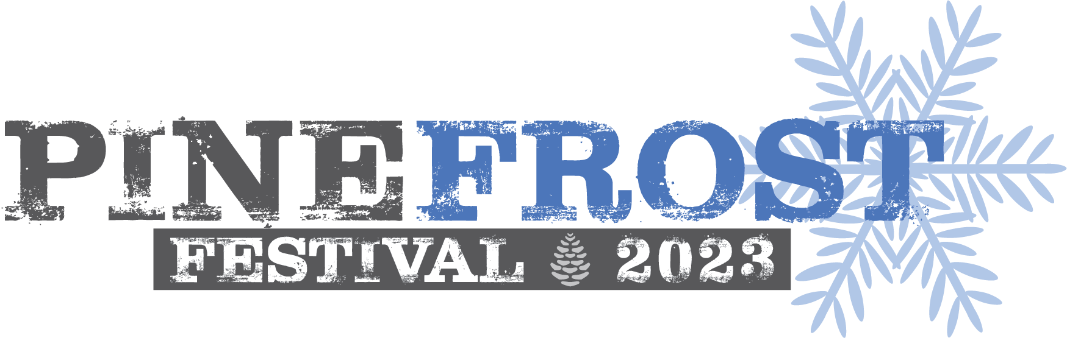

Cribbage Tournament
February 4, 2023

Registration Deadline February 1, 2023
Tournament starts @ 11:00am
$10.00 Registration Fee

This cribbage tournament is sponsored by Terry Foster
Single Player Format
Double Elimination Tournament
The cribbage tournament rules are attached.
Register online www.lapineparks.org
email chelle.kalmbach@lapineparks.org
Prizes awarded for 1st, 2nd & 3rd Place

Participant information
Name:____________________________________________________
Street Address:_________________________________________ Mailing Address:_____________________________ City:____________________ State:______ Zip:___________ email:_________________________________________ Home #:__________________________ Work #:__________________________ Cell #:________________________
How did you hear about this event? □ Website □ Facebook □ Flyer □ Word-of-Mouth □Publication:__________________ Consent and Liability Waiver
The undersigned does hereby release and discharge La Pine Park and Recreation District (LPRD), it's employees, including independent contractors, agents, officers, and directors for any and all claims, demands, causes of action, damage, loss of services, costs and expenses in any way resulting from any and all injury to person or property arising directly or indirectly out of the student's participation in the above activity, including any negligence on the part of LPRD, it's employees or agents.
Further, the undersigned agrees to indemnify and hold forever harmless LPRD, it's employees, including independent contractors, agents, officers, and directors from any and all injuries, damages, costs, attorney's fees whatsoever which may arise out of the student's participation in the above activity, including any negligence on the part of LPRD, it's employees or agents.
The undersigned further consents and authorizes the representatives if LPRD on the undersigned's behalf to obtain any necessary medical treatments or hospitalization or such other care necessary for the health and welfare of the named student, and the undersigned agrees to be responsible for and pay the costs of such medical treatment or hospitalization. This release of liability and indemnification agreement shall be binding on the heirs, successors and personal representatives of the student and undersigned.
I have read the foregoing release of liability and the indemnification agreement and acknowledge that the provisions are contractual and not a mere recital, and I understand I am bound by the terms hereof by placing my signature hereon.
Media Release
I hereby authorize LPRD to photograph me, take motion pictures of me, take video footage of me, and/or make electronic sound recordings of me (herein referred to as photographic or electronic reproductions). Further, I authorize the use of any such photographic or electronic reproductions of me for any purpose, including, but not limited to educational and other public media as may be deemed appropriate by LPRD (I understand that I may be identifiable from such photographic or electronic reproduction). I understand that there will be no financial or other remuneration for recording me, either for initial or subsequent transmission or playback. I waive any rights, claims, or interest I may have to control the use of my identity or likeness in whatever media used. Initial here if you do not agree to this___________
Refunds and Cancellations
If LPRD cancels the cribbage tournament, you will receive a full refund. If you need to cancel, notify our staff at least one week in advance to be eligible for a full refund.

Signature:_______________________________________________________ Date:________________________
For Office Use

Fee Total:_______ Date Paid:________________ Amount: $___________ □ Cash □ Card/Online □ Check #___________

Receipt #:__________ Received by:__________________

